Volume 1 | Issue 1 | NOV – DEC 2025
Received date | Accepted date | Published date

Title of the Article: Scientific Research in The Field of Business, Technology & Innovation Studies Journal

Author Name & Affiliation: Corresponding Author^{1*,} Second Author², Third Author³

¹Department of Law, Business and Management, Name of University, City, Country, Postal Code
²Department of Law, Business and Management, Name of University, City, Country, Postal Code
³Department of Law, Business and Management, Name of University, City, Country, Postal Code

Corresponding Author: Author’s Name Email: corresponding.author@univ.com

ABSTRACT
The abstract should begin on a new page following the title page and must be typed in single spacing for clear distinction from the introduction. It must succinctly cover all aspects of the study, as databases primarily index abstracts. This applies to original research, short communications, and review articles. The abstract must clearly state the research objective, methodology, key findings, and conclusion in approximately 150-200 words.

Keywords: Provide 4-5 keywords separated by a semicolon.

INTRODUCTION
The introduction should immediately follow the abstract. It should clearly explain the significance of the study in detail and establish the context and rationale. The objective or aim of the study must be clearly stated.

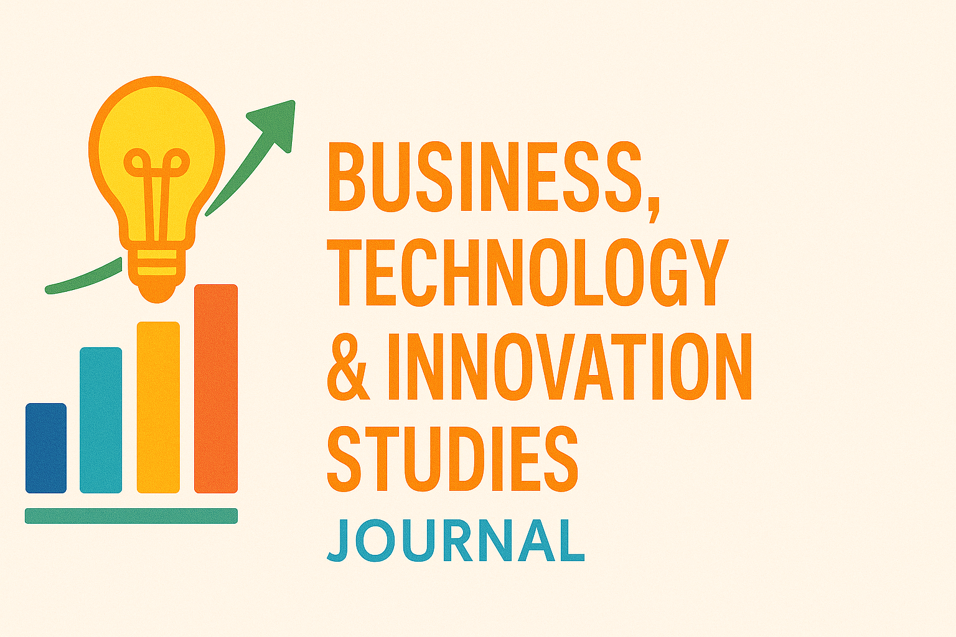

Figure 1: Description/Legend for Figure 1 goes here

MATERIALS AND METHODS
This section should describe in detail the methodology and procedures employed in the study. Ethical clearances or permissions involved must be explicitly stated.



Figure 2: Description/Legend for Figure 2 goes here

Avoid trivial technical descriptions but ensure new or novel methods are described adequately. Statistical methods should be clearly specified along with significance levels. TMP Universal Journal of Advances in Pharmaceutical Sciences encourages studies tested with appropriate statistical analysis.

RESULTS AND DISCUSSION
This section may be combined. Present experimental findings clearly and interpret results in relation to existing literature. Highlight significance, implications, and any new perspectives.

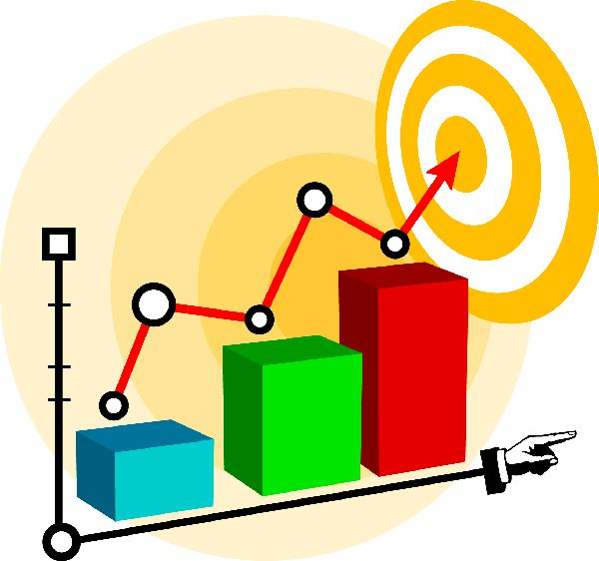

Figure 3: Description/Legend for Figure 3 goes here
Tables: Tables must be self-contained, complement textual information, and must not duplicate it. Each table should have a concise title, be numbered sequentially, and cited in the text. Submit tables in editable Microsoft Word format.

Table 1: Description/Legend for Table 1

Title | ID | Val1 | Val2
Title1 | 1 | 7 | 5
Title2 | 2 | 3 | 4
Title3 | 3 | 9 | 15
Title4 | 4 | 6 | 13

CONCLUSION
Provide a concise summary of the major findings. Reiterate how the results support the hypothesis or research question.

Acknowledgements: Acknowledge individuals, organizations, or institutions who provided support or assistance during the research.

Funding Sources: Mention all sources of funding, grants, or financial support received for the study, including grant numbers if applicable.

If no funding was received: "The author(s) received no financial support for the research, authorship, and/or publication of this article."

Conflict of Interest: Disclose any potential conflicts of interest (financial, professional, or personal) that could influence the work.

If none exist: "The author(s) declare no conflict of interest."

REFERENCES
Reference format: APA (American Psychological Association)

- References must be numbered consecutively as they appear in the text.
- Cite references in superscript within the text.

Example of Journal Article Citation:

Perlstadt H. (2025). Supply Chain Management and Performance in uncertain environment. Business, Technology & Innovation Studies Journal (BTISJ). 1(1), 01-39. DOI:

